CS -657 Intelligent Systems and Control
Assignment 4
Due April 19, 2017

The purpose of this assignment is to design a backpropagation neural network for implementing a digital half adder with noisy inputs. The adder using NAND gates is shown below which can be used as a guideline for your neural net implementation.

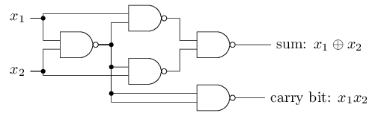

The following tasks are needed for the above problem:

- Decide on the number of neurons in the input, hidden and output layers.
- Chose suitable activation function, bias and learning rate.
- Generate a set of training values to implement the half adder. Your training data must include noise in the input. So instead of just 0 and 1 as inputs, add random noise between -0.2 to +0.2 to the inputs. However outputs must be either 0 or 1.
- Train the network using the training sets in item 2. Produce graphs to show the mean squares error (learning rate, etc.) versus Epoch.
- Now generate 100 test values with noise for the inputs and record the outputs
- Find the errors in your the neural net solution in step 5.
- Investigate the effect of learning rate, and draw the appropriate graph.
- Write a report about your procedure, findings, conclusions, etc.

Note: Please develop your own program for the neural network, i.e. do not use a neural network package such as Matlab.

